GUIDE ON HOW TO RUN DermaTrace.ai
Prerequisite downloads: Python 3.11 , Git 2.45+
i. Pulling the file from the GitHub repository
1. Go to the command terminal (use win + R cmd OK on Windows).
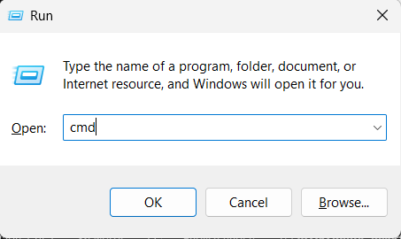
Type git clone https://github.com/nqfw/DermaTrace.ai/ in the command terminal.
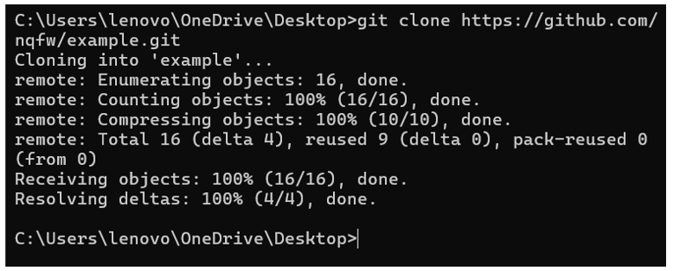

ii. Downloading dependencies
1. Locate the DermaTrace.ai Folder, open requirements.txt, then right click the file and click on “Copy as path”.
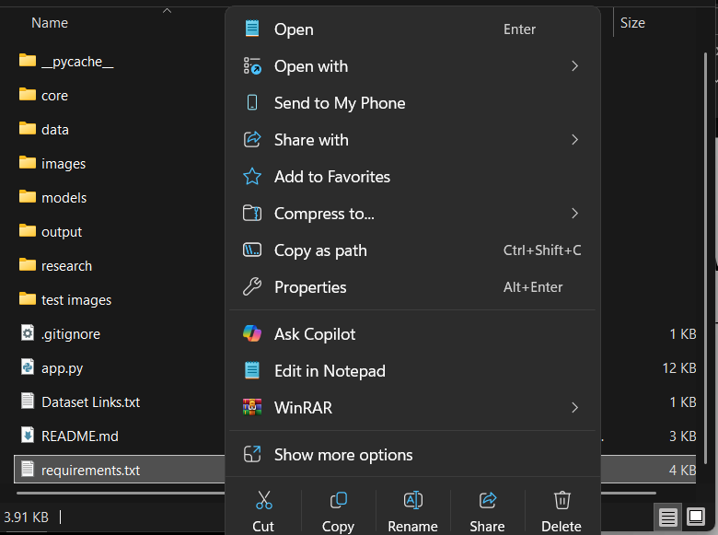
2. Run pip install -r “C:\Users\path\to\file” (Path was copied in step 1), then wait for dependencies to install.
3. Wait for the dependencies to install.
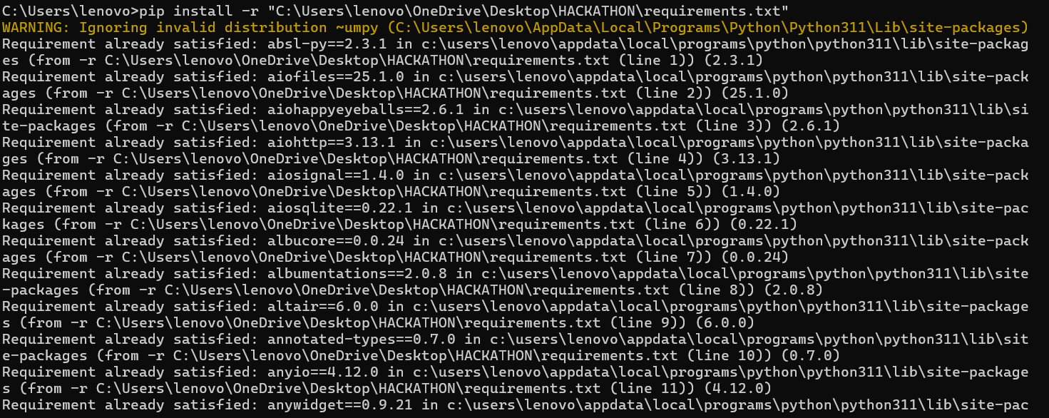
iii. Running the app
1. While in the terminal go to the file via cd “path” (You may find the path by selecting the folder, then by clicking on “Copy as path”
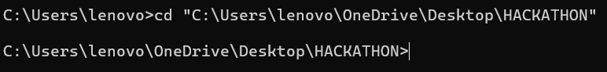
2. Type streamlit run app.py to execute the code.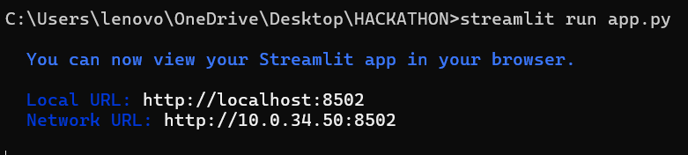

3. Two tabs, one for the Streamlit dashboard, and another for the FiftyOne audit will be opened.
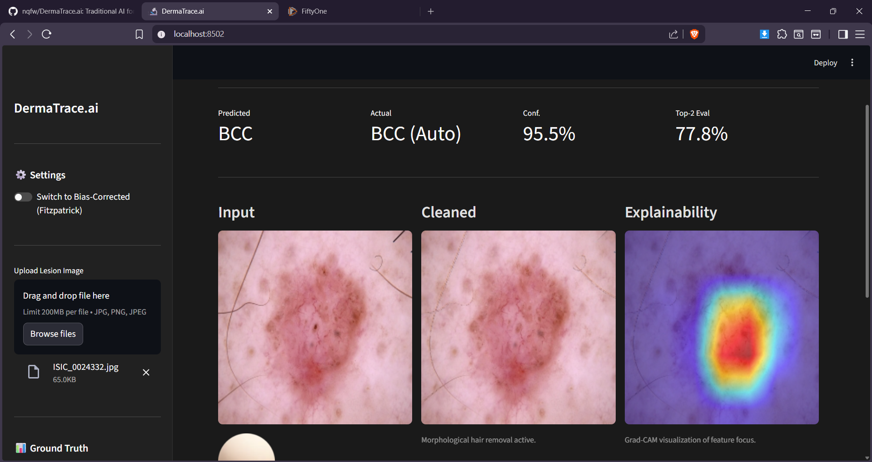
4. Files can be updated via “Browse Files”. Once the files are uploaded, the images are automatically saved to the FiftyOne tab, which can be viewed upon refreshing the dataset (You may need to scroll down).
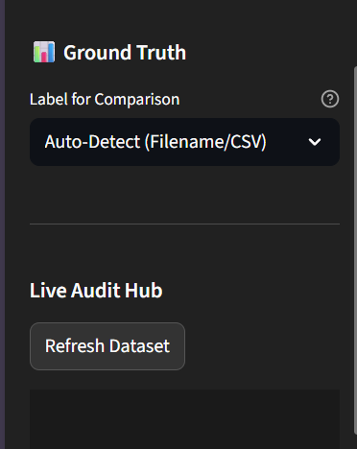
5. Upon navigating to the tab for FiftyOne, all uploaded images can be seen and audited later. 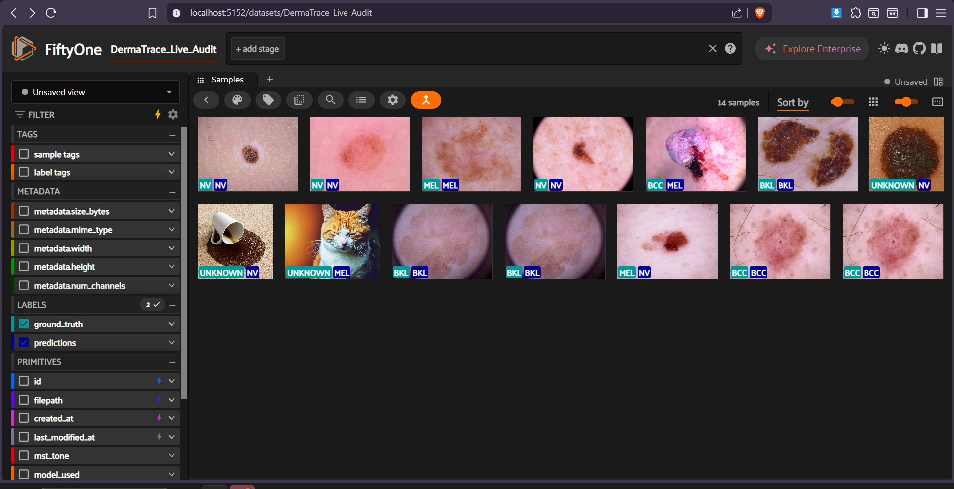
6. One done with usage, close both tabs, then click Ctrl+C on the terminal to properly close the app.
DermaTrace.ai is an assistive technology (XAI). It is designed to augment the diagnostic process for dermatologists and general practitioners, not to replace professional medical judgment. This software is currently for research and assistive auditing purposes.

